**Homework 10 HTTP Wireshark Analysis**

For this homework, use the same TCP wireshark trace as for Homework 6 and 7. A web browser is using TCP to set up a connection to the web server, requesting a web page to be downloaded and the web server responds sending the contents of the web page in multiple subsequent TCP segments to the client. The link MTU is 1500 bytes.

*Note: To analyze the above packet trace for this homework, ensure that HTTP processing is enabled in wireshark by going to* ***Analyze > Enabled Protocols*** *and checking all HTTP items. You may also want to filter on HTTP to ignore the TCP segments.*

Given the above packet trace, complete the following exercise.

1. Examine the contents of the HTTP GET Request:
   1. What is the relative URL of the web page being requested? How is this determined?

**Personnel/bio.htm determined through get request**

* 1. What is the absolute URL of the web page being requested? How is this determined?

**Http://gaia.cs.umass.edu/personnel/bio.htm**

* 1. What is the version of the HTTP protocol being used? How is this determined?

**1.1 because it is a get request**

* 1. What is the format of HTTP GET Request Message?

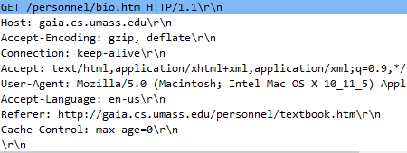

* 1. There are several “header” lines in the HTTP GET Request, such as Host, Accept-encoding etc. What type of information is contained in each of these header lines and what is the purpose? (You may need to look this up in HTTP specifications. See reference.)

**The Host request-header field specifies the Internet host and port number of the resource being requested, as obtained from the original URI given by the user or referring resource (generally an HTTP URL,**

**The Accept-Encoding request-header field is similar to Accept, but restricts the content-codings (section 3.5) that are acceptable in the response.**

**The Accept request-header field can be used to specify certain media types which are acceptable for the response. Accept headers can be used to indicate that the request is specifically limited to a small set of desired types, as in the case of a request for an in-line image.**

**The User-Agent request-header field contains information about the user agent originating the request.**

**The Accept-Language request-header field is similar to Accept, but restricts the set of natural languages that are preferred as a response to the request.**

**The Referer[sic] request-header field allows the client to specify, for the server's benefit, the address (URI) of the resource from which the Request-URI was obtained (the "referrer", although the header field is misspelled.)**

**The Connection general-header field allows the sender to specify options that are desired for that particular connection and MUST NOT be communicated by proxies over further connections.**

**A cache seeing this header field will act correctly even if the cache does not understand the community cache-extension, since it will also see and understand the private directive and thus default to the safe behavior.**

1. Examine the contents of the HTTP GET Response:
   1. What information does the status line of the HTTP Response contain?

OK

* 1. What is the message format of the HTTP GET Response?

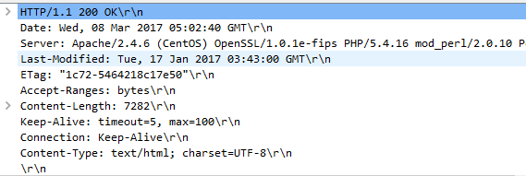

* 1. There are several “header” lines in the HTTP GET Response, such as Last-Modified, ETag etc. What type of information is contained in each of these header lines and what is the purpose? (You may need to look this up in HTTP specifications. See reference.)

The Date general-header field represents the date and time at which the message was originated, having the same semantics as orig-date in RFC 822.

The ETag response-header field provides the current value of the entity tag for the requested variant. The headers used with entity tags are described in sections [14.24](https://www.w3.org/Protocols/rfc2616/rfc2616-sec14.html#sec14.24), [14.26](https://www.w3.org/Protocols/rfc2616/rfc2616-sec14.html#sec14.26) and [14.44](https://www.w3.org/Protocols/rfc2616/rfc2616-sec14.html#sec14.44).

**The Accept-Ranges response-header field allows the server to**

**indicate its acceptance of range requests for a resource:**

The Content-Type entity-header field indicates the media type of the entity-body sent to the recipient or, in the case of the HEAD method, the media type that would have been sent had the request been a GET.

* 1. What is the contents of the “body” of the HTTP GET Response?

HTML page

* 1. Is this HTTP exchange using persistent connections? Why or why not? What does “persistence” mean in the context of HTTP connections?

YES it is using a single TCP connection to send and receive multiple HTTP requests/responses (KEEP ALIVE). HTTP CONNECTION MANAGEMENT EARLIER VERSIONS ONLY SUPPORTED 1 connection (CONSTANTLY OPEN CONNECTION).

* 1. What mechanisms does HTTP used to avoid using stale data in web caches? How do they work? Any evidence these mechanisms are used in this exchange?

Conditional Get, if modified date, yeah in header

Note: You may need to do some research to answer the above questions by referencing HTTP technical specifications on the web.   
Reference: <https://developer.mozilla.org/en-US/docs/Web/HTTP/Headers>